
Matthew Glanfield presents…
BBO Infinite Profits
A beginner’s fast-track to the infinite profits of the web…


All material contained in this e-book is Copyright © 2008 Glanfield Marketing Solutions Inc. and may not be reproduced, redistributed, or resold without prior written consent from this company.

Legal Disclaimer: While all efforts to provide correct information have been made, we cannot guarantee any success or any sort of income from reading this e-book. We do have confidence that if you read and study this e-book, and APPLY what is taught, that you can see great wealth through your own Internet business. However, we cannot legally guarantee anything. We are not responsible for the loss of income, time, or any damages that applying what is taught in this e-book may cause (although we don’t think that any of that will happen!).
Preface - or “why I created this e-book”

I know what you’re thinking right now. You’re thinking, “I don’t really care why you created this e-book, I just want to make money online!”

And hey, I agree with you! I hate buying e-books where they spend the first 50 pages telling you how great they are and how much money they have made and how great the Internet is and why you should consider getting into it and all that other boring stuff…

Sigh… Why not just teach the stuff that makes money?

That is why I created this e-book, and that is why you should stop everything else you are doing right now, and read through EVERYTHING here as quickly as you can.

Sure, you could just read the first few chapters and then go and apply it (you ARE going to apply this, aren’t you?), but then you’d be missing out on the bigger picture.

That’s right, the bigger picture.

What is this bigger picture? Well, I can tell you what it isn’t. It isn’t:

- How to make money by selling e-books
- How to make money by selling other people’s products (i.e. affiliate marketing)
- How to get more traffic
- How to make more sales
- How to build a list

All of those things are great, and they do help you to fulfill your dreams, but they aren’t what make a business a profitable business.

Chapter 1 – The Infinite Profits System

So what makes a profitable business?

Ah, that is the right question. And to answer that in its fullest you will need to read this entire e-book.

Don’t worry. I won’t fill this up with a ton of fluff that will take up 150 pages to teach what could be taught in 10.

I’ll cut through the B.S. and the false ideas that are out there, and I’ll show you where the REAL money is.

And no, it’s not in e-books.

And no, it’s not truly “in the list.”

And no, it’s not in affiliate marketing.
So what is the “big secret” of the “bigger picture?” It’s quite simple actually. In fact, I can sum it up into one word.

Ready?

Here it is:

Continuity.

You should highlight that right now. Oh, you don’t have a highlighter? Ok, I’ll do it for you:

Continuity.

Yup, that’s the big secret. And most people still haven’t figured it out. Most people are too busy selling their $67 e-books to as many people as will buy them, trying to cash in on the $30 profit margin that they get when an affiliate sells their product.

How many e-books would you have to sell to make $100,000 per year if you made $30 per e-book (after affiliate commissions, PayPal fees, etc.)?

Let’s do the math:

$100,000 / $30 = 3333.3333…, or about 3334 e-books per year, or a little over 9 per day.

Let’s say you get a 1% conversion rate (we’ll talk about what this means later, but let’s just say that it means for every 100 people that visit your site, one purchases). That would mean you would need over 900 visitors per day ON AVERAGE for the entire year.

Sound like a lot? It is, unless of course you have a ton of huge partners ready to send out promotions for you.

You don’t? Well, then you may want to listen to what I have to say. ;)

All kidding aside, there is a much easier and better way to make $100,000 in a year, and most people will be able to do it within their first year.

Oh wait, I just got a phone call from my lawyer. Hold on a second…

Matthew: “Yes?”

Lawyer: “You can’t tell people that most people can make a certain income in their first year!”

Matthew: “Why not?”

Lawyer: “Because then you’ll get sued when they don’t succeed!”

Matthew: “Sigh… Alright, I’ll tell them what I really mean…”

Ok, I’m back. My wonderful lawyer wanted me to tell you that I can’t guarantee any income.

Well, I didn’t. However, allow me to clarify:

If you apply what I will teach you in this e-book, you have the POTENTIAL of making $100,000+ in your first year.

Clear enough?

And just a side note, the one big thing that keeps people from this potential is a simple lack of focus and a lack of action-taking.

If you want to be like 99% of the failing “business owners” out there, simply do nothing and you’ll succeed just like they have.

Wait a second! I never finished telling you all about continuity and why it is included in the Infinite Profits system!

Well, you’ll find out in this chapter, I promise. And for those of you who don’t even know what the word “continuity” means, you’ll be an expert on it by the end of this book.

So what exactly is the Infinite Profits System? Well, it can be broken down into 6 simple steps:

The Infinite Profits System
1. Find a niche.
2. Create a front-end product.
3. Make sales.
4. Create a serious back-end continuity product.
5. Link front-end to back-end.
6. Create more front-end products.

Don’t worry, if you aren’t familiar with terms such as “niche”, “front-end”, “back-end”, or “continuity”, it will all be explained to you here.

Now, before we go any further I realize that you may have seen certain elements in this system before. Obviously finding a niche (AKA “knowing what you are going to sell”) is essential to any business.

However, what really makes this system stand out and work so incredibly well is steps 4 through 6.

Allow me to explain – remember how we were talking about how hard it would be to make $100,000 just selling e-books? Well it’s true!

When I first started teaching people how to make money through affiliate marketing (that was the second business I started), I started with a $97 e-book (the price changed around, but it was around $50 - $100 at any given time).
I was able to make quite a bit of money, but it wasn’t until I created YourSqueezePage.com, which is a continuity product, that my revenue sky-rocketed. We ended that year (the FIRST year of that particular business) with around $300,000 in revenue.

I could not have done it without the continuity part.

That allowed me to harness the power of residual income, and also the power of back-end products.

Ok Matthew, what is a “continuity product?”
I keep using the phrase, so I better explain it.
A continuity product is a product that people pay a subscription fee to access. Typically this is a monthly membership site, where people pay $10 - $500 per month in order to gain access to training, software, or any other benefits.
The reason this is so effective and profitable is because you aren’t just getting one-off sales, you are making residual income.
Let’s do a quick calculation. If you were able to add only 50 members per month (that isn’t much) to a $20 per month continuity program, you would be making how much in only 6 months?
50 members x 6 months x $20 per month = $6,000 per month!
What about after a year?
50 members x 12 months x $20 per month = $12,000 per month!
The key here is that once you get a new member, they continue to pay month after month (provided you do things right).
Alright, let’s get back to what we were talking about.

We’ll talk more about continuity products in a later chapter.

Hopefully by this point you aren’t too overwhelmed. If you are, don’t worry, just take this one step at a time. While the system may look difficult it really isn’t, mainly because it focuses on building your business, not just creating it.

Chapter 2 – Who on earth are you gonna sell to?

A HUGE word of warning – do NOT spend all of your time on this step, or you’ll NEVER make any money.

Choosing your “niche” is probably the most important part of your business, and yet I still think that people spend too much time on it. When I decide to start a new business in a new niche, I spend about 30 minutes to an hour researching and choosing a niche.

That’s it. One hour at most.

That’s all I really need. The Internet is one of the easiest places to do two things:

- Competitive analysis – learn all about people ALREADY making money
- Economic analysis – learn all about what people are ALREADY buying

You are not going to try to discover a “new market” that nobody else is selling to. You don’t want to invent a new type of product that nobody has ever heard of before but that everybody will need.

Your goal is simple:

GO WHERE PEOPLE ARE BUYING AND SELL TO THEM!

If I had a motto I think that would be it. Let me spell this out in another way:

- Find out what people are looking for.
- Find out if the profit margins are good.
- Check out how much competition there is.
- If the profit margins are good, and there is a lot of competition, you’ve found a great niche.

That’s all there is to it. The step that is probably the hardest is #1, not because you don’t have the tools, but because it is so broad.

The way I see it, there are two main types of products that you can sell on the Internet. They are:

- Information products (i.e. info-products)
- Physical products (i.e. e-commerce)

There are combinations of the two, but for all intents and purposes I am going to keep those two categories separate.

This e-book is going to focus on the first category, so all of the advice that I am about to give you is about how to find a great niche market for an info-product business. I use a slightly difference approach for finding what people are looking for when I start an e-commerce store.

The reason for this is that the mind set of consumers who are buying info-products is much different than those who are shopping for normal physical products (think about the last time you were in a department store as opposed to the last time you were on an info-product sales page).

While information products are some of the easiest to create, and have the highest profit margin, I am going to suggest that you stick to markets that fall under one or more of the following qualifications:

3 Types of High-Potential Info-Product Niche Markets
- How to make money.
- How to save money.
- How to improve your lifestyle.

While you can definitely succeed in markets that don’t fall under these three types, it will be much easier if you play to these needs.

Now, do NOT think that I am encouraging everybody to start teaching Internet Marketing (i.e. How to make money through creating an Internet business). If that is what you really want to do, go for it! But don’t choose that market simply because you think it is the only place where you can make a lot of money.

I’ll give you a few examples of each category. Some examples may fall under more than one category.
1. Examples of Markets in the “How to make money” Area
- Internet Marketing and its many branches
- Real Estate
- How to start your own [FILL IN THE BLANK] business
- Foreign Exchange
- Investing

2. Examples of Markets in the “How to save money” Area
- How to pay less taxes
- “Do-it-yourself” markets (e.g. home improvement, car repair)
- How to pay less for gas
- How to find [FILL IN PRODUCT TYPE] cheap

3. Examples of Markets in the “How to Improve your Lifestyle” Area
- Weight Loss
- Eating Healthier
- Quitting Smoking
- Overcoming Addictions
- Overcoming Disorders (e.g. ADHD)
- Family Improvements

There are MANY more examples that I could give, but I think this gives you a good idea of what we are looking at.

Basically the idea behind choosing a market within these three categories is that we are playing the basic human emotional needs. Beyond basic survival everybody wants to live better lifestyles, and that is perceived to come through having more money (or saving money) or through better health or better relationships.

Remember, people purchase based on emotion and justify their purchase based on logic, so if you can’t appeal to the emotional side of your customers, you are going to have a VERY hard time making any sales.

Some places to get ideas…

If you are stuck with ideas of areas that could help, here are a few places that I often go to get ideas of what types of information people are looking for.

1. ClickBank (www.clickbank.com)

Visit ClickBank’s marketplace to see the categories that they have set up. They list over 10,000 information products, so you can bet that the categories listed there will be lucrative ones.

2. Alexa’s Web Directory (www.alexa.com)

Looking at any web directory will give you plenty of ideas to start with. I like Alexa’s directory because it tells you how many sites it has listed right beside each directory.

Look for sub-categories with large amounts of websites and you’ll know you have found something that people are looking for.

3. DON’T Use eBay (www.ebay.com)

One place I suggest that you don’t use is eBay.

Now, why would I include a site that I wouldn’t suggest using? It is simply because I would use eBay if I were starting an eCommerce store, because they focus more on physical products.

99% of the information products that are being sold on eBay are about how to make money with Internet Marketing and by selling on eBay, so you won’t get a wide variety of ideas from this site.

Start with the idea, and then apply the litmus test…

When I was in high school chemistry class (*shudder*) I learned about something called a “litmus test.” Basically if you had a liquid that you were trying to determine the acidity of, you could dip a piece of litmus paper into it.

The litmus paper would instantly change color, after which you compared it to a chart to determine how acidic the liquid was.

The beauty of the “litmus test” is that it is nearly instantaneous.

Well, the Internet provides many resources so that we can create litmus tests of our own for niche market ideas.

Now, while the tests I am about to show you aren’t instant, they are pretty close! If you give me an idea I can tell you within 5 minutes if it has a high potential for success or failure.

Do you like the sound of that? I sure hope so.

No more “guessing” whether something will work.

No more “trying something out” to see if it will work.

No more hanging on to an idea just because YOU think it’s a good one!

You have to be prepared to scrap what appear to be good ideas when they fail these litmus tests miserably. Failure to do so will result in, well, failure!

(Slight disclaimer: These litmus tests aren’t 100% accurate, but they are WAY better than our own opinions on what works.)
Litmus Test #1 – Are People Searching For It?
- Go here:
https://adwords.google.com/select/KeywordToolExternal
- Type in one to three keyword phrases that best describe your market (e.g. weight loss, lose weight).
- If there are a lot of related keywords with a decent amount of search volume, it passes!
If there are a lot of related keywords with a TON of search volume, you probably want to narrow your topic.
Otherwise, it fails…

I’ll give you an example of a pass and a fail (with screenshots to help you out).

Good Example #1 – dog training (fits in “Lifestyle Improvement” category)

I typed in dog training in the tool and got this (see next page):

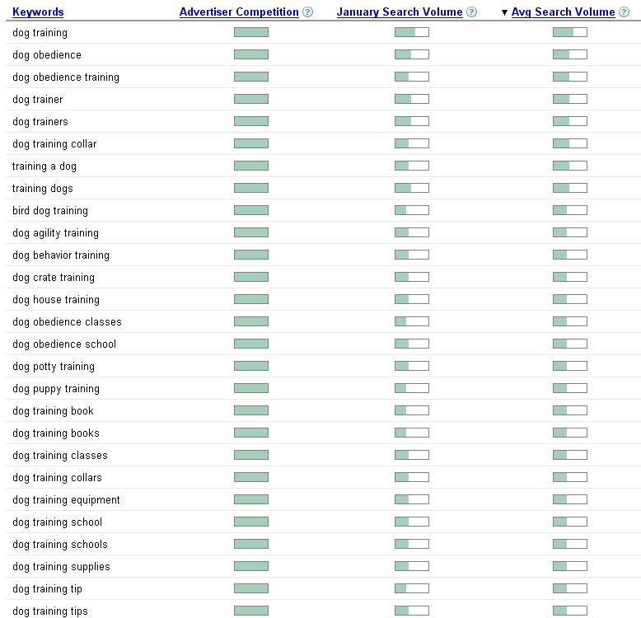

Now, what we are looking at here is “Avg Search Volume” and not anything else.

As you can see there are a lot of related keywords (the list goes on beyond the screenshot above) that receive a decent amount of traffic (i.e. around half a bar).

That means that “dog training” passes the first litmus test.
Bad Example #1 – real estate (fits under “Make Money” category)

This is what I got when I typed in the term “real estate.”

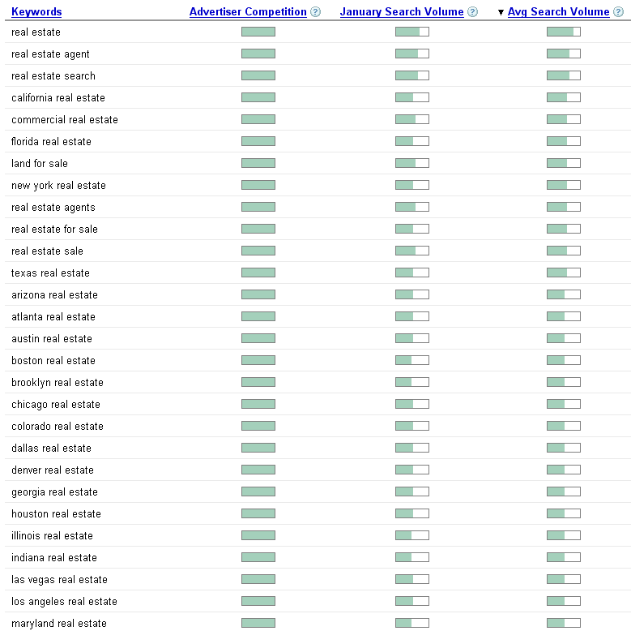

As you can see the keywords aren’t really that related to somebody looking for an info-product.

Wait a second! You said real estate was a good market!

And it is. However, that doesn’t mean that you are going to go and make a website about “real estate.” What I said was a good market is teaching people how to make money from real estate, not on how to get an agent or on properties in certain areas.
Litmus Test #2 – Are There Good Profit Margins?
- Go to www.google.com and type in a couple of your main keywords.
- If there are a lot of sponsored ads, then there are good profits to be made.
If not, then this test fails.

It’s one thing to have a lot of “searchers” in a market, but what you really want are buyers.

Unfortunately it’s not always easy to know how many of those searchers are buyers, so we are going to do a bit of reverse economic review here.

To do this I need to explain a small portion of what I learned in first year University economics. This has to do with supply and demand.

You have probably heard of this before. Where there is a group of people looking to spend money on a certain product or service (i.e. demand) there will always enter businesses to sell those products or services (i.e. supply).

Every market always finds some sort of equilibrium, where new companies are entering and old ones are failing, and the good ones are sticking around to serve more and more customers.

What we want to find is a market with a high amount of demand. So how do we determine that? We look for a high amount of supply.

Remember, where there is a lot of demand (i.e. customers), there will be a lot of supply (i.e. vendors).

But how do we tell if a market has a lot of supply? Do we simply look at the number of websites that show up for a particular search? Of course not! All that tells us is the number of pages that Google knows of that mention your keywords in them, not suppliers!

Instead we look at advertisers. If there are a lot of advertisers (i.e. companies paying for advertising) in a market, then there MUST be profits! Otherwise the companies would soon lose money and stop advertising.
Of course there are always new companies in markets who start advertising before making any profits (that’s how you have to start!), so there will almost always be some sort of advertisers in any market.

That’s why we look for markets with LOTS of advertisers, because it proves that there must be high profit margins!

So here is what you do:

- Go to www.google.com.
- Type in your keyword phrases.
- See how many sponsored ads there are for that phrase.

Take a look at this screenshot for the search phrase “recipes”:

(on the next page)
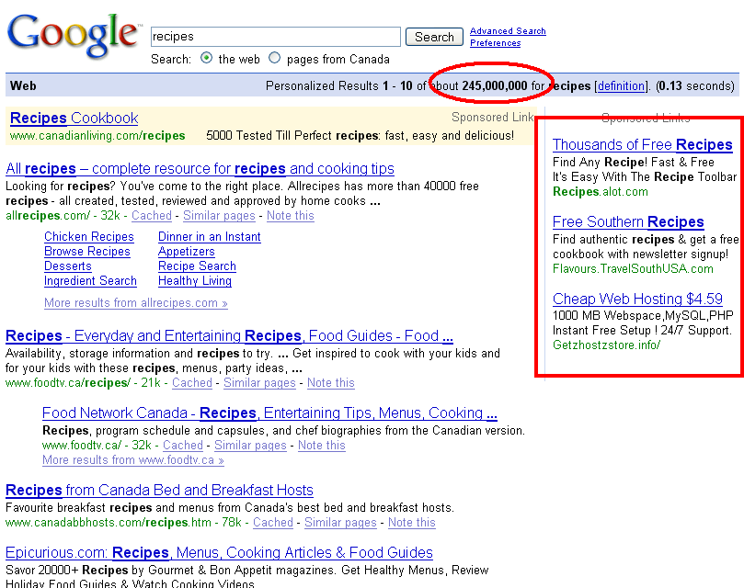

I put a red box around the sponsored ads, and a red circle around the number of “natural” listings (i.e. web pages that show up for free because Google thinks they should).

As you can see there are TONS of websites that mention recipes (at least 245 million!). However, there are only three advertisers that we can see, and one of them doesn’t even sell recipes!

This tells us that while there are plenty of searches for recipes, the profit margins are really low.

Let’s look at another keyword, “quit smoking”:

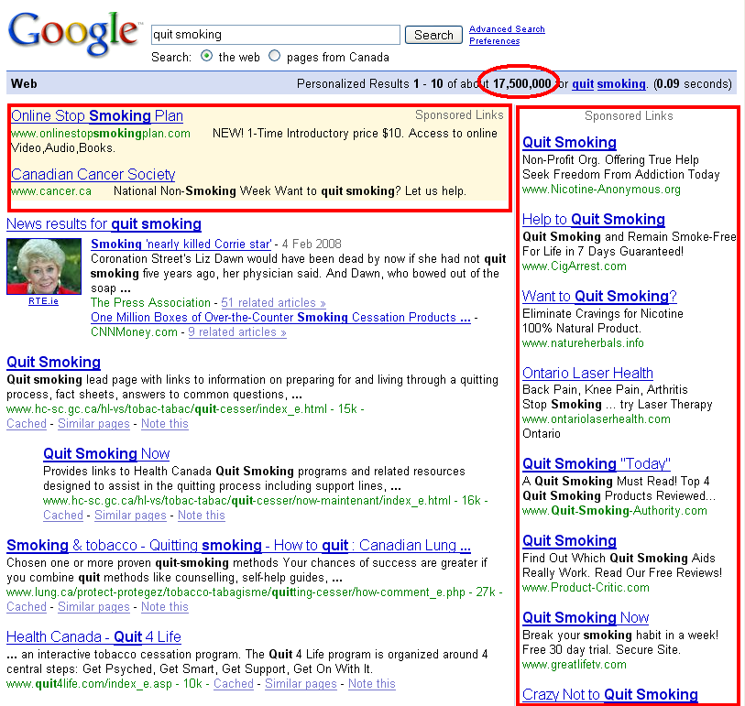

As you can see there are a LOT of advertisers that want to teach you how to quit smoking (there are even more that aren’t shown on the screenshot above).

That tells me that there must be good profit margins in selling products related to quitting smoking.

Now, you may ask me exactly how many advertisers you should see before determining that your market passes the test, and I’ll tell you that there is no “magic” number.

However, since most people aren’t happy until they hear a number, I’ll say 10.

There you have it. If there are 10 or more advertisers, then it passes litmus test #2!
Litmus Test #3 – Is There Competition?
- Type in your main keyword phrases.
- Visit the top results in Google.
- Visit the sponsored ads in Google.
- Are the majority of these sites considered competition?

Just a small warning: this is going to be VERY counter-intuitive. Just trust me on this.

You absolutely want there to be good competition!
What I mean by “good competition” is:

- They know how to build a list (i.e. they are using squeeze pages and opt-in forms).
- They know how to write a good sales letter.
- They offer good products.
- They offer info-products.
- (optionally) They are search-engine savvy.

Now, why would you want good competition? If I were starting an e-commerce store I would actually do the exact opposite and look for markets where the competition is not very savvy.

However, in the info-product realm of the Internet, there is one underlying factor that can accelerate you to wealth in a tremendously short period of time…

PARTNERS!

The way I see it there is no such thing as competition! They are all potential partners!

As you will discover later on in this e-book, one of the best ways to build your business is through partners and affiliates (i.e. other people who sell your product for a commission). It is how I have built hundreds of thousands of dollars of revenue, and it is how you will do the same.
Sure, there are all sorts of other methods to drive traffic, and I do suggest that you use them. But the one that can make the biggest difference the fastest is partners.

So, if you enter a market with no marketing-savvy competition, then you are going to find it hard to form solid partnerships that will move you forward the fastest.

If the market passes these 3 litmus tests, then you have a winner!

Let’s go over these tests one more time:
Litmus Test #1 – Are People Searching For It?
- Go here:
https://adwords.google.com/select/KeywordToolExternal
- Type in one to three keyword phrases that best describe your market (e.g. weight loss, lose weight).
- If there are a lot of related keywords with a decent amount of search volume, it passes!
If there are a lot of related keywords with a TON of search volume, you probably want to narrow your topic.
Otherwise, it fails…

Litmus Test #2 – Are There Good Profit Margins?
- Go to www.google.com and type in a couple of your main keywords.
- If there are a lot of sponsored ads, then there are good profits to be made.
If not, then this test fails.

Litmus Test #3 – Is There Competition?
- Type in your main keyword phrases.
- Visit the top results in Google.
- Visit the sponsored ads in Google.
- Are the majority of these sites considered competition?

Clear enough? Then go find your market and move on quickly!

Honestly, you should not spend more than a few hours on this, mainly because it will hold you up from actually making money.

Speaking of making money, let’s talk about making your first product.

Chapter 3 – Makin’ Your First Product Infinite-Profits-Style

Now that you know who you are going to sell to, it’s time to talk about what you are going to sell them.

In the past I have taught people to spend the first month or so of their business building time working on building a list and doing affiliate marketing (i.e. selling other people’s products), and then creating their own product.

My philosophy behind this was that selling other people’s products would help you to find out what people were buying, and also would give you some time to build a list.

Well, I hate to say it, but I was wrong.

Affiliate Marketing is great, but it is NOT where you should start…

Don’t get me wrong, I love affiliate marketing. In fact it is where I started out when I created my first business.

In fact, I made roughly $20,000 in affiliate commissions before I wrote my first e-book.

So why would I tell you not to do the same thing?

Because I was NOT running an info-product business at the time! I was running a business model that is somewhat different than what I do now.

And therein lays another secret…

Different business models require different systems. While the basics of business will work with all types of businesses (i.e. customer acquisition, customer service, conversion rates, etc.), systems aren’t always the same.

If you were to open a restaurant, there would be a very different system than if you were to open an e-commerce store, even though you would still use the same basic business principles in both situations.

The same applies for Internet businesses. There are many models of Internet businesses, and each requires its own system.

Let’s get back to it now…

Ok, so the first thing you need to worry about once you know which market you want to enter is the product that you are to create.

This step should not be rushed, but at the same time shouldn’t take too long (I wouldn’t take more than one month to complete it, and you might even be able to do it within a few days, or even one day!).

Here are the steps to creating your own info-product:

Infinite Profits Info-Product Creation
- Decide on a hot topic.
- Choose your preferred easy format.
- Design your product for quickest completion.
- Complete your product!

Let’s go over each of these steps in detail:

1. Decide on a hot topic.

A hot topic is a topic that everybody wants to learn more about, and they just can’t seem to get enough.

Hot topics are usually:

- Fundamental difficulties that people have (e.g. losing weight without much effort)
- New technologies / stuff that everybody is talking about (e.g. online video, the latest fad diet)
- Controversial subjects (e.g. succeeding where others usually fail)
- Desperate subjects (e.g. how to quickly sell your home)

There are more things that could fall under this classification, but the list above should give you some ideas.

How do you know if you chose a good topic?

There are several things you can do to test if a topic is a good one. Here are a few suggestions:

- Visit the forums in your market and see if they are talking about it.
- Visit the forums in your market and ask the members if they are interested in it (don’t blatantly advertise though).
- Set up an Adwords campaign with a squeeze page that talks about the subject and see what the response rate is like.
- Run a survey with your list (if you have one).

I particularly like #3. You can go to http://www.yoursqueezepage.com, pay $1 for a trial account and have a squeeze page (i.e. a short opt-in page where you can collect names and email addresses) set up in a matter of minutes.

(You’ll also need an auto-responder. I recommend the one at http://www.bbomail.com)

You can then run over to http://adwords.google.com and set up a Google Adwords campaign in about 10 minutes, and start getting traffic in less than 15 minutes (most of the time, sometimes it takes a little longer).

Spend $0.05 per click and $100 and you’ll have sent 2,000 people to your squeeze page, and you will have built a list of between 100 and 500 depending on the quality of your squeeze page.

Next, send that list of people a quick survey, asking two questions:

- What is your biggest question about [INSERT TOPIC HERE]?
- If it were reasonably priced, would you buy a product if it taught you [INSERT TOPIC HERE]?

It sounds simple, and it is, and it works!
“But I don’t know anything about those topics!”
I can hear the cries of outrage right now – “How do I teach something I know nothing about?!?”

You’re absolutely right. You can’t teach something you know nothing about, and creating info-products is all about teaching stuff!

Here are three solutions to this problem:

- Only choose something you know a lot about.
- Learn more about the subject first.
- Use somebody else to teach the material.

The first one is obviously ideal, but it isn’t always possible. The second one is also a good idea, and is something that you will need to do.

However, do you really want to spend the first two to six months of your business just learning about the topic that you are going to teach?

I don’t. I prefer to make money a little sooner than that!

That is where #3 comes in to play. Instead of relying on your own non-existent knowledge about a subject, why not just use somebody who already knows a lot about the subject?

This is the secret to how I quickly built info-products fast and easy…

Are you paying attention? Good! Then I want to tell you something that will allow you to by-pass becoming an expert.

(Actually, you do eventually want to become the expert, but in the meantime why not leverage some other people’s expertise?)

There is more than one way to teach others about a certain topic. I’ll list them here:

- You are the teacher.
- You are the reporter.
- You are the interviewer.

#1 requires you to know the topic. #2 and #3 don’t.

Think about it – what are the most popular programs watched on T.V.? The news! Everybody loves to read the newspaper and watch the T.V. to have the facts reported to them.

I once attended an Internet Marketing seminar when I first started my business. When I got back I wrote a post on my blog saying “Hey, do you want to know what I learned?”

Everybody went crazy! I had all sorts of replies saying “Yes! We didn’t get to go to that $2000 seminar, so tell us EVERYTHING!”

They were looking to me not as the expert, but as the reporter. I blogged more about the various things I learned, and my readers loved it.

You can do exactly the same thing when you create your products. You simply become the source of all the great information out there. You compile all the knowledge of the experts, and you sell it!

(Now don’t go taking copyrighted materials and using them. You’ll need to rephrase, restructure, and retell everything in your own words, otherwise you are in violation of copyright laws.)

The third method is my favorite. It is to become the interviewer. Once again, people love to watch others get interviewed, especially if the interviewer makes it appear that they have the listener’s best interest in mind (not like those stupid infomercials where the “interviewer” just can’t get enough of how great the product is).

Here’s a simple formula that I have used to make fast products, and that you can use to make a product within one day:

- Choose your topic.
- Contact an expert (or two or three) in that field and request to do a teleseminar (you’ll be surprised how many are willing to do this).
- Grill them for 45-60 minutes on that topic.
- Have the audio transcribed.
- You have a product!

I have made products that have sold from $7 to hundreds of dollars using this model, all simply having me as the interviewer, and not the source of information!

But why would an expert agree to do an interview?

Simple, they want more exposure, and you can give it to them! Tell them what you plan on doing with the call and also offer to promote their product (with your affiliate link of course) in the call.

Here is what you can tell them:

- You will be selling the audio and transcripts.
- You will be recruiting several JV partners who will help with sales. That means more people will get the interview.
- Your goal is to sell thousands of copies over the next year, getting more buyers to the interviewee’s website.
- You will also directly promote the interviewee’s website in your follow-up email series.

If you can think of other ways to help the interviewee, then do it!

You can refer to the resource area for service providers for recording interviews and teleseminars at http://www.bboinfiniteprofits.com/resources.php.

But I don’t want to do a teleseminar!

Fine!

There are still other great types of info0products that you can create. I’ll go over two now.

1. Video Products

Video products are extremely sought after in most marketplaces. While most people don’t mind reading, almost everybody loves watching video to learn instead.

Now, I don’t want to dwell on this for too long mainly because video products can take a lot of time to produce, so I am going to make two suggestions:

First, Use Camtasia to Create Quick High Quality Videos

Camtasia (found at http://www.techsmith.com/camtasia.asp) is a wonderful piece of software that allows you to record the screen.

I use it two ways – to record the screen as I show people how to do certain things, or to record a PowerPoint presentation as I speak into a microphone.

In both cases people LOVE the end result.

But that’s not even the best part. This is…

Second, Sell The Product Before Its Done!
This is my favorite part about making video products (this can work for teleseminars too).

If you write an e-book you usually need to finish it before you sell it. However, if you create a video “course” then you can release the videos over time, removing the necessity to finish the entire project before you sell it!

Oftentimes what I do for my “video series” products is create the first one or two videos, and then sell the entire course.

Of course I tell those buying the product that the other videos will be released over the next few days or weeks, so there is no deception here.

In fact, when you first release the product you can even make that a selling feature! Tell your customers that you will answer their questions as you go throughout the course and customize future videos according to their needs!

You can still plan out all the videos that you will be creating, but now you’ll get feedback so that you can make even better videos based on what you know your customers are struggling with.

2. E-Books

The other type of product that you can create is an e-book. If you love to write and you have the discipline to sit down for 5-10 hours per day for a week, then you can quickly crank out an e-book within just a few days.

The advantage to an e-book is that people are used to them and people still love to read them.

The disadvantage is the large amount of work that needs to be put into creating one. That is why I rarely write e-books anymore.

Wrapping this all up…

Let’s recap. At this stage you need to choose a hot topic to cover and create a product.

On the next page I will show you a chart that you can use to help decide what style and type of product you want to create.

Remember, any will work, but you need to create the product fast.

An Easy Map to Choosing a Style of Product
- Choose a Topic.
- Are you an expert on the topic?
  - If yes, then go to 5.
  - If no, then go to 3.
- Can you quickly learn the topic?
  - If yes, then go to 5.
  - If no, then go to 4.
- Host a teleseminar with an expert. END HERE.
- Could you spend 20-40 hours in one week writing an e-book?
  - If yes, then go to 6.
  - If no, then go to 7.
- Write an e-book. END HERE.
- Create a video product. END HERE.
Remember this is only a guideline. If you are an expert and want to do a teleseminar, then do one! It is completely up to you.

Now go and create your product!

Chapter 4 – Sellin’ Your Product to the Masses

You’ve probably been able to guess that it is one thing to create a product but it is a whole ‘nother thing to sell it!

There is a battle going on right now. It is a battle of trying to get products recognized and sold to the masses that they were intended to reach.

Most people lose this battle, mainly because they don’t realize that there are two major sides to it:

The Battle of Selling Products
- Having a product that people actually care about.
- Getting that product in front of those same people.

Luckily for you we’ve already won the first half of the battle by choosing a hot topic. It has been my experience that most new marketers want to come up with something radically new and different that people will love.

However, since it is new, it doesn’t cover the qualifications for #1 in the battle above, because people don’t realize that they need it!

I won’t dwell on that because you should have already overcome it in the last chapter, but I did want to mention it so that you could see more of the big picture of why I wanted you to choose a hot topic in the first place.
Let’s dive right into how you are going to sell your product.

While writing this e-book I sent out a survey to my list of 20,000+ interested Internet entrepreneurs with a single question:

“What is the biggest problem that is stopping you from making money online?”

Amongst the answers were things such as focusing on one thing at a time, time, money, and getting traffic.

However, another answer was also very common:

TECHNOLOGY!

Most people have no idea how to make a website to sell their product! It’s one thing to use Microsoft Word® to create your product, but it’s quite another to create the website in order to sell it.

This fact alone keeps a LOT of people from ever starting their business, simply because they don’t know how to make a website!

Now, I can understand the frustration behind this – I’ve seen many people deal with it. However, I am going to give you a secret that so few people even think about when it comes to making a website.

Are you ready for this uber-crazy secret?

I have to warn you, it is quite radical and may challenge the very way you look at your Internet business.

In fact, once you read the secret you may leap up and start running around the room waving your arms in the air screaming at the top of your lungs “Why didn’t I think of that?!?” making your spouse and children wonder if you have finally gone crazy…

Can you really handle this?

If not, then stop reading now!

Ok, but don’t say I didn’t warn you…

Here is the secret of life, the Internet, and everything…

(I hope you’re sitting down.)

…

…

…

OUTSOURCE IT!
(i.e. pay somebody else to do it for you)

Ahem…

Are you ok?

I know that was probably the biggest shock that you have ever experienced, so I’ll give you a moment to get over it.

Think about it – if you wanted to open a restaurant, would you build the building yourself?

Would you create all the marketing brochures and paraphernalia yourself?

Would you create all of the hamburgers, French fries, and milkshakes yourself?

Of course you wouldn’t! You want to focus on the business end of things, the marketing end of things.

And yet when people come onto the Internet, they think they have to not only make the hamburgers, but build the building and serve the customers all by themselves!

It’s like we’ve taken several steps backwards in evolution now that we have better technology in front of us.

Ok, yes, if you know how to web design you have a slight advantage (sometimes it is a disadvantage as you may not be as good as you think).

However, just like a restaurant owner doesn’t have to know jack about good building structures, you don’t have to know anything about FTP, HTML, PHP, MySQL, or any other acronyms that so commonly scare the bejeebees out of us.

Now, outsourcing isn’t the golden bullet that will solve all of your problems, mainly for one reason:

(Most) Web Designers Don’t Know ANYTHING About Internet Marketing!

Sure, they’re great graphic designers. Yes, they can make something look pretty for you. They do a great job of making a wonderful brochure.

But that’s not what you want. You want a website that not only looks professional, but that will actually turn visitors into customers!

That is why I am going to teach you how to structure your web site, but not how to build it. If you know how to structure it, you can pass this on to your web designer who will know how to build it.

Think about it as you being the architect and the web design being the construction crew.

Here is the basic structure of ANY info-product website:

1. Sales Page

2. Payment Processing
3. Register Page
4. Download Page

That is all you really need for your first product. Let’s go over each of these now so that you can understand what each of these mean.

Step 1 - The Sales Page

The sales page is where you, well, sell your product! It is usually the home page of your website. For an example of a sales page visit www.bboadwords.com.

Let’s take a look at the various components of a good sales page:

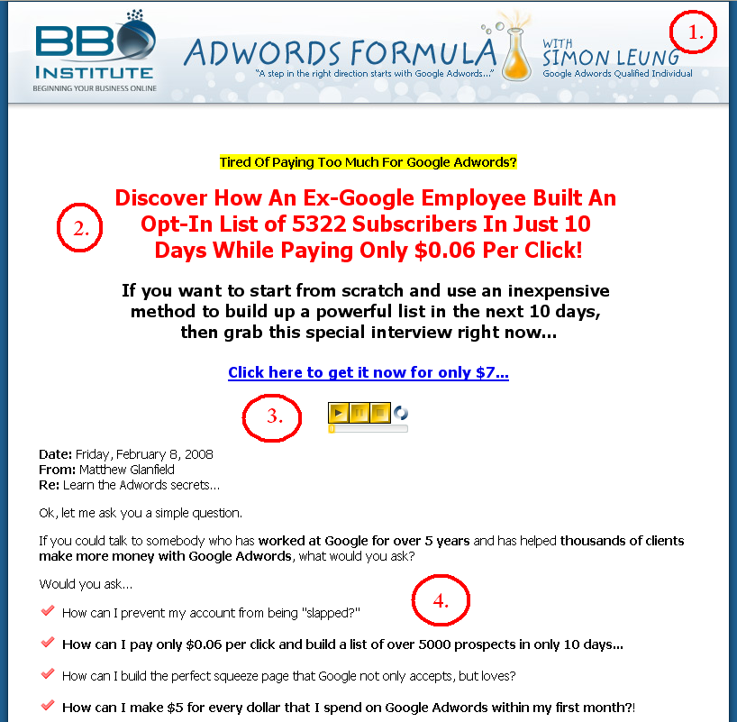

I have placed a screenshot here of the first part of the sales page at www.bboadwords.com. I will go through each of the components marked by the numbers circled in the picture (those aren’t on the actual sales page, I added them to show you the various parts).
1. The Header Graphic.

This part is optional. I actually recommend that you don’t have a header graphic at first, mainly because I find that in most cases you get better sales without one.

However, if you really care about the fancy graphics, then make sure you keep it clean, simple, and have it focus on the benefits of what the customer will get with your product.

(If you look closely you’ll see that www.bboadwords.com is actually not positioning me as the expert. It is an interview with ex-Google employee Simon Leung. I STILL make products using others as the experts, because it works!)

Standard sizes for the header graphic are typically 800x100 to 800x200 pixels in size (if you don’t know what that means just pass it on to your designer and they’ll know what to do).

2. The Headline.

This is the most important part of your ENTIRE sales page.

Believe it or not, that big ugly red headline is the reason that the product sells. Most people who are new to Internet Marketing resist the idea of having a big fat headline at the top of their sales page, mainly because they think it looks too “hypey”.
Like it or not, they have been tested and proven to work time and time again, so you’d better use one if you want to make sales!

A good headline will catch the attention of the visitor (you’ve got about 5-10 seconds to do that) and will make them want to keep reading.

This is achieved in two ways:

- The font.
- The wording.

The font I like to use is red bolded Tahoma at about 20-26pts (once again, pass it on to your web designer), with maybe a black sub-headline and a bit of yellow highlighting.

Check out a few of these websites to see what I mean:

http://www.yoursqueezepage.com
http://www.affiliatemarketingformula.com
http://www.bbotrafficclub.com

The wording is a bit tricky as it requires a bit of skill in copywriting. The best way to write a great headline is to look at what other people have done and mimic it as much as you can, and then test out different ones of your own to see which one works best.
Remember, the purpose of your headline is not to sell your product, but instead to persuade the visitor to continue reading the sales letter (most people don’t).

You can achieve this by placing the greatest benefit of your product in the headline.

Here are a few examples:

Warning: Using Squeeze Pages Can Actually LOWER Your Profits, Decrease Your List Size, And Seriously Tick Off Your Website Visitors!

If you aren't properly testing every component of your website's squeeze page, you are wasting 90% of your advertising dollars.

I'll show you how to create a highly-profitable, highly-converting, money-pulling, relationship-building squeeze page,
in less than 5 minutes...

The “Warning” part catches the visitor’s attention, and then tells them something awful about squeeze pages (I assume the visitor knows what a squeeze page is when they get to my site).

The other great benefit is also highlighted in yellow (“in less than 5 minutes…”).

Here’s another one:

After two years of solid 6-figure marketing business growth,
you are now able to find out...

"How A 23-Year-Old University Student
Cracked The Simple Formula That
Allowed Him To Quit His Job And Build
A $1000 Per Day Business Within Only A Few Months..."

Introducing: The 27-Day Affiliate Marketing Formula

You're about to discover the easiest way to get started with making money on the Internet, just by selling other people's stuff!

See the benefits? ($1000 per day, only a few months, easiest way to get started, etc. etc.)

And just in case you don’t quite get it yet…

WHAT?!?

You Mean We Got
1,000 Unique Visitors
And No Sales?

Why Not?!?

Sound familiar? Well, now even you can not only get more traffic, but make more sales, with our FREE BBO Traffic Club membership...

In short, headlines are:

- Attention grabbing
- Benefit driven
- Big and obvious
- Made to get the visitor to read more
- Made to build curiosity

Oh, and your web design should NOT do ANY of your sales page copy (i.e. the words). You should type up what you want in a document and have them turn it into a web page.

You do not want them writing your headlines. It’s just awful (trust me).

(No offense to web designers out there – there may be a few exceptions to this, but most of you are great at graphics, but lousy at sales copy).

3. Audio (or video).

This is also optional, but I find that it increases sales if you have some sort of audio or video explaining the benefits of what the visitor is going to buy.

The media should be short (30 seconds to 1 minute) and should focus on benefits, not on you or the product. It should usually auto-play (i.e. start playing without the visitor clicking on it), but should be easy to find and stop (no hidden audio players please).

Check out the recommended resource area for resources for adding audio and video to your website.

4. The salesletter.

The salesletter will form the largest part of your sales page. Now, this isn’t a copywriting course, so I won’t go into a ton of detail about the salesletter (just mimic what you see other people do, that will give you a great start).

Here are a few tips on writing your salesletter:

- Use bullet points as much as possible.
- Paragraphs should be short.
- Focus on benefits, not the features of your product.
- Use bolding and highlighting to bring out important phrases.
- Write the letter with skimmers in mind.

The last tip is probably the most important. Most people won’t read your salesletter; they will just skim through it.

Keeping this is mind, design your salesletter for the skimmers. You can do this a few ways (I will be repeating myself a bit here, but these points are important):

- Use sub-headlines (i.e. the big fat red sentences that you see at www.bbotrafficclub.com).
- Use bullet points instead of several paragraphs.
- Break up your content with colored boxes (once again, see www.bbotrafficclub.com)
- Bold and highlight key words and phrases that you want the skimmer to read.

Copywriting is a skill that you must develop, but it may take some time.

However, even a poorly written salesletter can make sales. My first salesletters were awful! And yet I was able to make close to $92,000 in a single week with a poorly written salesletter.

Not bad, eh?

Let’s look at the second half of another sales page so that we can see the remaining elements:
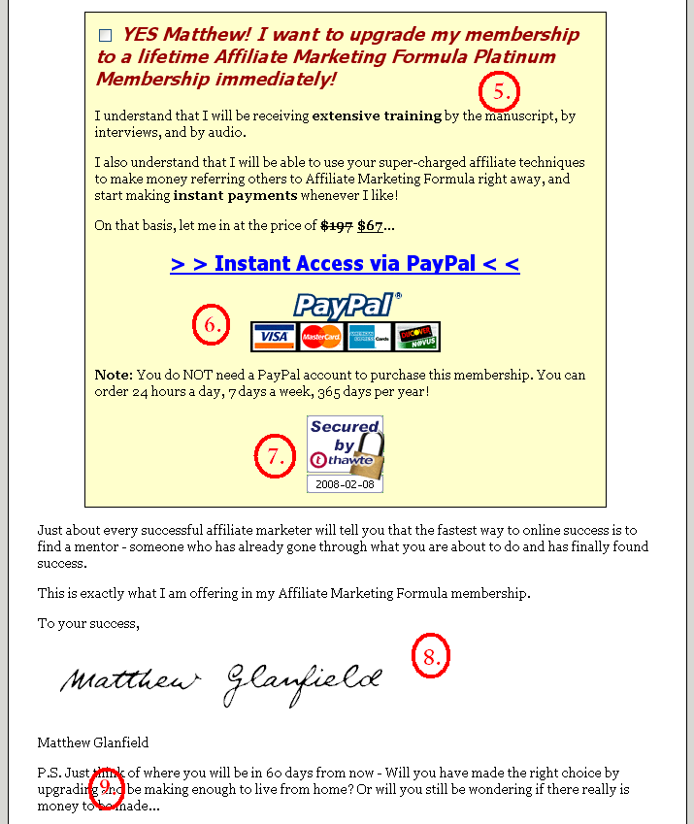

5. The order box.

The order box is simply where you summarize what the visitor is ordering. You can simply copy the style that you see on the screenshot above to get the desired effect.

6. Payment link and images.

Believe it or not, most people don’t assume that you accept credit cards, so you should make it quite clear by including images of the major credit cards right beside the order link.

Also, I like to add in something like “We accept orders 24 hours a day, 7 days a week” because, once again, believe it or not, not everybody understands that the Internet is always on and that you can always take orders.

7. Trust and Security Symbol(s).

This part is optional. If you include some sort of security or trust symbol (I have some suggestions at http://www.bboinfiniteprofits.com/resources.php) then your sales will more than likely go up.

8. Your signature.

Hey, this is a letter, isn’t it? Then why not include your signature! It’s been shown to increase sales.

Of course don’t include your REAL signature. You can use an online program to fabricate one for you (go to http://www.bboinfiniteprofits.com/resources.php for resources on where you can do this).

9. P.S.

Remember, we are writing this for skimmers. Skimmers often scroll to the bottom of your sales page to see what the price of your product is.

That is why it is important to include a couple of benefit-driven P.S.’s as well.

Make sure you focus on one or two of the core benefits of purchasing your product, and then invite the visitor to either purchase or read more.

10. One more important thing to add.

There is one more thing that I need to discuss before we move on to Step 2. This is collecting email addresses of interested prospects.

One of the best ways to build your income quickly is to build a list of prospects who are interested in what you have to offer, but may not be ready to buy.

However, with the sales page the way it is right now, we aren’t really accounting for that.

There are two ways to fix this. They are:

- Use a squeeze page before visitors come to your sales page.
- Add an opt-in box to your sales page.

What is a squeeze page?
A squeeze page is a small web page that forces the visitor to either enter their name and email address or leave.
They are very effective in building your list, but can sometimes lower your sales if they aren’t used properly.
Learn how you can create squeeze pages easily and quickly by going to www.yoursqueezepage.com

I personally prefer method #1 most of the time, but method #2 also works quite often.

In either case you will need to offer something of value for free in exchange for the visitor’s name and email address. This is often a free report, a free chapter, a free video, or a free preview of the product you are selling.

I’ll give you an example of each.

To see a website that uses a squeeze page followed by a sales page go to www.yoursqueezepage.com (which coincidentally allows you to create squeeze pages rather easily and quickly).

The other option, method #2, can also work quite effectively.

Here is a screenshot of a website that uses a hover pop-over:

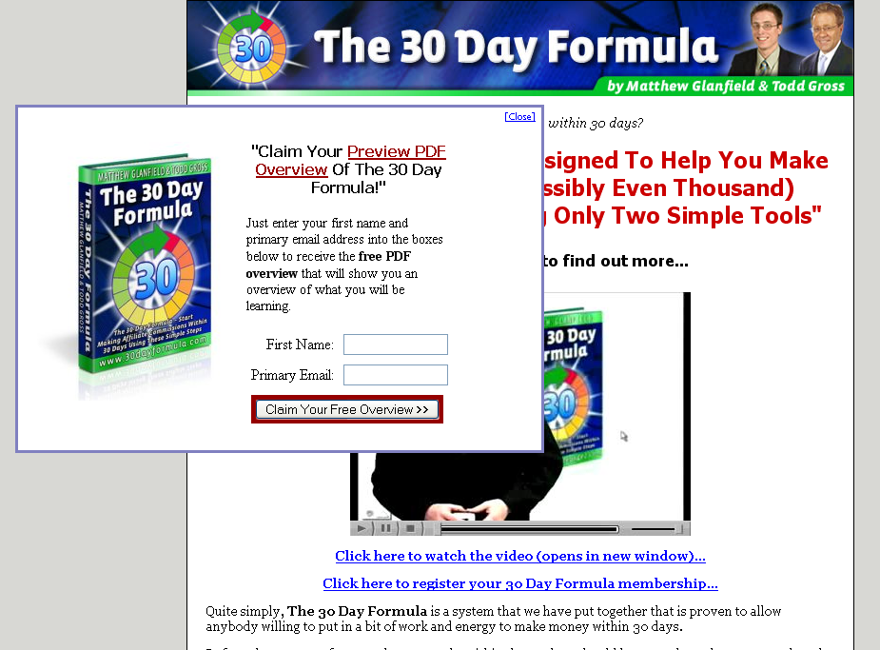

As you can see the pop-over box offers something of value (a preview PDF) in exchange for the name and email address of the visitor.

Once the visitor is on your list you can work on selling your product to them, as well as building a solid relationship by delivering high quality content and other promotions via email.

How do they get on my “list”?
Simple (ha!). You store them on an auto-responder.
An auto-responder is a program that will store the names and email address of your prospects and customers and allow you to email them all at once.
My preferred auto-responder is at www.bbomail.com.

Step 2 - The Payment Processor

Once a visitor clicks on the order link of your sales page they are taken to your payment processor.

The great thing about this step is there is very little you need to do about it! All you have to do is sign up for one of the payment processors on the recommended resource page (www.bboinfiniteprofits.com/resources.php) and spend about 10 minutes adding your product.

There is one question at this point that I should cover – how much should you sell your product for?

There is no one answer, as this is something you should test out.

However, here is what I suggest. Price your product between $40 and $70 for make money and save money niche markets, and between $20 and $50 for any other market.

The best way to find out what price to charge is to test (i.e. try out different prices and see which one yields the most revenue).
There is one more question to cover in this section – how much should you give affiliates when they sell your product?

When you use one of the recommended payment processors that I have on my resource page, you will automatically get an affiliate program built in for your product.

An affiliate program allows you to recruit affiliates. An affiliate is somebody who promotes your product in return for commissions when they make sales.

For your first product I recommend giving either 50% or 60% in commissions, depending on how much your product costs. If your product is less than $50, I suggest 60%. If it is more than $50, then I suggest 50%.

Of course if you are willing to sacrifice early profits to build your business even faster then I would offer 75% commissions as this will get affiliates to promote even more.

We’ll talk more about affiliate marketing in the next chapter.

Step 3 – Registration Page

After the visitor has paid for your product they will be returned to the page of your choice on your site.

The next page should be a registration page, where they need to register to download the product.

The reason you want to force them to register is so that you can collect their name and email address to:

- Send updates of new versions of your product
- Send useful content to build a solid relationship of trust
- Promote affiliate products to make even more money
- Promote your future products and continuity programs

The best people to promote to are customers, so make sure you get their details!

Here’s how it works. After making the purchase the customer is returned to a page like this one:

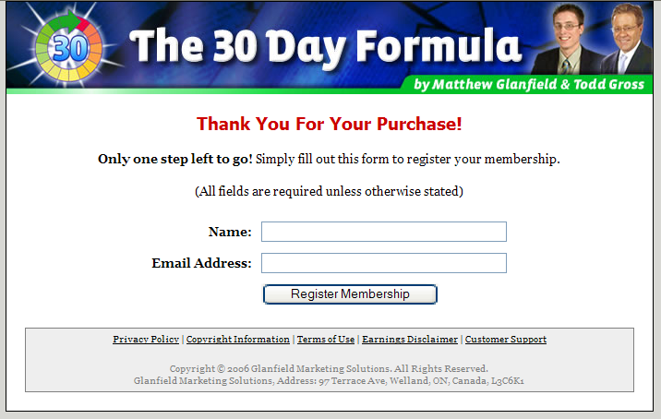
The visitor is asked to enter their name and email address to access the product.

The name and email address is stored in an auto-responder, just like in your squeeze page or your pop-over box.

Actually, the register page is really just a glorified squeeze page, except this time the visitor is going to want to give you their details as they want to access the product they just purchased.

Think about it – they just entered their credit card information, do you think they’ll have a problem giving up their email address? Nope.

Once the customer has registered, they are sent to the next step.

Step 4 – Download Page

The download page is where the customer, well, downloads your product!
(I know, this is amazing stuff, but just you wait.)

Here is the download page from www.bboadwords.com:

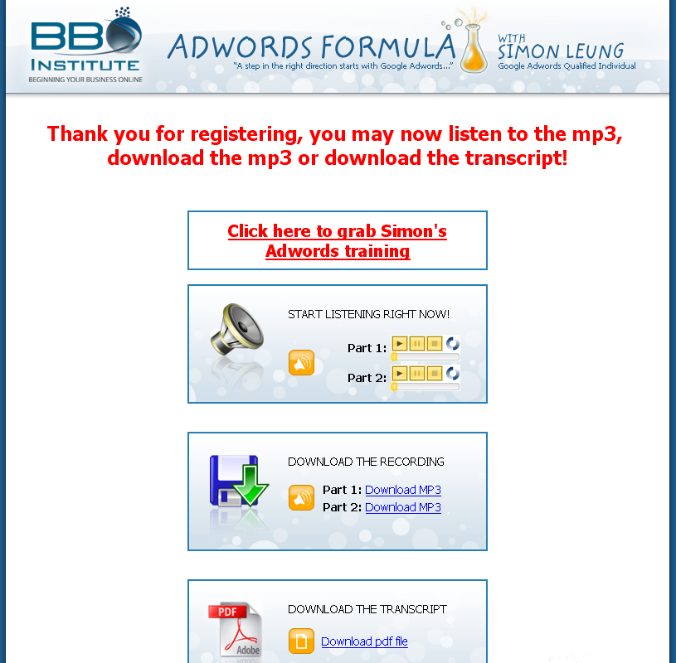

It got cut off as it is pretty long, but I think you get the idea.

Notice a few things:

- I give them what they paid for (duh).
- I promote Simon’s full course (remember how I said you want to help out the expert you interviewed?)
- That’s it!

There really isn’t much more to a download page than that.

You don’t need a complicated members’ area with all sorts of fancy doodads and widgets.

However, there is one other thing that you can’t see on that download page:

An invitation to join your affiliate program!

Now, this won’t work in all markets, but if you are teaching people how to make money, why not invite them to join your affiliate program and make money selling your products?

I always make a lot of effort in recruiting more affiliates right from my own customer base, and I have had a lot of success with it.

(Forget about this if you are in a niche outside of Making Money, but don’t let you discourage you from going into those niche markets, as they have other advantages in other traffic methods).

Let’s put this all together now…

So now you know the basic elements of a website that sells your info-product. How are you going to put it all together?

Like I said before, if you don’t know how to web design, outsource it! I’ll have some recommended web designers on my resource page as well, so check it out at www.bboinfiniteprofits.com/resources.php to find out who can help you make your website.

Of course, if you can do it yourself, then you’ll save a few hundred dollars, but be prepared to spend some time getting this all set up.

Now, what is a website without traffic?

Chapter 5 – Gettin’ Eyes On Your Site

Hopefully I don’t need to convince you that simply building a site won’t make you money.

What? You don’t believe me?

I’ll make this quick – imagine building a wonderful store with everything everybody wants at exactly the right price they are willing to spend…

…on the moon.

Would you get any customers? Well, if NASA sends out more people to the moon you might get a few window shoppers, but I doubt they will have brought along their credit cards…

In other words, if you don’t drive traffic to your website, then you won’t make sales.

There, I’ve made my point. Can I teach you how I get traffic to my websites now?

Excellent! Let’s get started!

My Favorite Method of All…

…will be the last method I talk about. Let’s start with Google Adwords instead.

Google Adwords…

Essentially you can easily start getting traffic within 30 minutes of having your website ready to go if you use Google Adwords.

However, it doesn’t work quite as easily as that. Although you will be able to get traffic easily enough, it doesn’t mean you will make any sales from it.

Also, Google Adwords can be very expensive, especially if you are not careful.

That is why I am going to suggest that you not use it at first, mainly because it takes two major things:

- Time.
- Conversion testing.

In order to have a Google Adwords campaign work well you have to be willing to invest between $500 and $1000 and also spend about a month testing and tweaking various aspects of your Adwords campaign.

Also, it is a little harder to get Adwords traffic to convert into sales than other types of traffic, so this requires you to do some extensive conversion testing (i.e. testing different elements on your sales page to make sure you are maximizing sales).

However, if you are willing to put the time and money into it, and you want some of the best Adwords training that the ‘net has to offer, then I strongly suggest you go here:

http://www.myfirstadword.com

Not all of the training is free there, but if you are going to invest a few hundred dollars into Adwords, then for a few dollars more you can do it right.

Instead of Adwords I want to focus on some free sources of traffic that you can use to great effect.

Here are my “freeish” traffic sources…

The reason I say “freeish” is because the traffic methods are free, but they are greatly facilitated if you purchase certain software to automate the process (in most cases).

Let’s talk about two awesome methods that can really bring in traffic quickly that will convert into sales.

Freeish Traffic Method #1 – Article Marketing

First off, article marketing. Simply put article marketing involves taking 500-750 word articles and submitting them to the hundreds (and thousands) of article directories.

The articles are of your own authorship (or of a ghostwriter – more on this soon), and deliver good content regarding whatever your niche market is all about.

There are two major benefits to article marketing:

- Direct traffic.
- Incoming links to your website.

Whenever you submit an article you are allowed to also submit an Author’s bio. In the bio you can talk about yourself and your websites all you want. You are NOT allowed to promote your websites in your articles.

The Author’s bio is the perfect place to put an advertisement for your website or for a free giveaway. However, most author’s don’t use the bio very well, writing something like this (taken from an actual article):
[NAME REMOVED] has been gaming and writing about gaming for years. He currently edits game guides for [COMPANY NAME REMOVED].
You can view his work at [URL REMOVED]
Visit the site to read the blog, view the weekly free tip and keep up on all the latest products.

Now what’s wrong with that bio? It doesn’t have a call to action.

To illustrate what I mean by this I will show you a better bio:
Do you want to learn more about how I do it? I have just recorded a 25 minute CD called "[NAME REMOVED]"
Request your free copy here: Click here for your free CD

This isn’t the best bio I’ve ever seen, but it is way better than the one before, because it tells the visitor what to do.

Now, allow me to write what I believe is a great bio:
Are you tired of working like a slave at your job? Then download my free report on How To Fire Your Boss at http://www.example.com. You’ll learn how to work from home with your own Internet Marketing business.

What makes this a great bio?

- There is a clear call to action (download my free report at…)
- It is an advertisement (nobody really cares about the author)
- I put in keyword rich links that link to different pages of my site.

Now I probably won’t go into #3 much more than that for now because it involves talking about some search engine optimization stuff which I don’t think is the greatest place to start.

Basically the end goal is to get your articles out to as many sites as possible so that others read them and visit your site.

Interestingly enough it doesn’t take very many articles before you really start to see results.

Here’s how it works:

- Write (or have written) a 500-750 word article about something in your industry.
- Write an advertisement for your author’s bio.
- Submit the article with the bio to article directories.
- Repeat with more articles.

If you want ideas for structuring articles just go and look at the thousands of articles at www.ezinearticles.com. As for where to submit your articles, go to www.google.com and type article directory.

This sounds like a lot of work!

It is.

I know, it sucks. I don’t like lots of work either.

So here is what you do. You change the structure a bit, like this:
- Go to www.scriptlance.com and hire ghostwriters to write articles for you for $5 to $15 an article.
- Write your own advertisement (shouldn’t take more than 5 minutes).
- Use www.getarticlemarketer.com to submit your article quickly to 1000+ low to medium quality sites.
- Use www.getarticlesoftware.com to submit your article somewhat quickly to a few hundred high quality sites.
- Repeat.

You can even take it further and replace steps 3 and 4 with:

- Hire somebody to submit the articles for you.

I hired somebody I knew for $10 an hour and they could use the software at www.getarticlesoftware.com to submit my articles to hundreds of directories within 3 or 4 hours (i.e. $30 or $40 per article – not bad!).

One word of warning…

Articles written by ghostwriters will not be of very high quality, but they will still get the job done. If you are really picky, then you should write your own articles (it really doesn’t take that long anyway, probably 30-60 minutes per article).

That’s really all there is to article marketing!

When I first tried out this method I submitted seven articles to a few hundred article directories, and then forgot about it.

One year later I was still receiving daily signups from those articles.

Sure, there weren’t very many of them every day, but for 20-30 hours of work one year earlier I think I was rewarded rather well.

Your Action Plan

I don’t suggest that article marketing be your only source of traffic, mainly because it is unpredictable in nature. However, here is what you should do:

Write and submit an article at least ONCE PER WEEK.

If you are feeling especially ambitious you can up the ante by starting out with five to ten articles and having those submitted, and then slow to a normal rate of about one per week.

(Not that more article submissions wouldn’t help, but more that other methods should be used as well.)

Freeish Traffic Method #2 – Video Marketing

This is very similar to article marketing, except instead of submitting articles, you submit videos.

Video marketing often is much more powerful than article marketing for driving immediate traffic, but is balanced by the fact that it doesn’t help you out in the search engines quite as much (just trust me on this, it would take a whole chapter just to explain why that is the case).

Basically you are going to create 2-5 minute length videos and submit them to the video sharing sites.

Here is the basic process:

- Create a video that is less than minutes in length.
- Submit the video to the major video sharing sites.
- Repeat.

That’s it!

Why such short videos?

The name of the game with video marketing is exposure, and since you get one page on each video sharing site per video, the more videos you can make, the better.

Rather than make one 20 minute video, break it down into 5-10 shorter videos. That will literally increase your traffic from videos by roughly 5-10x!

To get a great list of video sharing sites that you should submit to, Wikipedia will help you out:

http://en.wikipedia.org/wiki/List_of_video_sharing_websites

But I don’t know how to create videos!

This is a little harder to outsource. In fact, I don’t suggest that you get anybody else to do your videos – it would be too expensive and just as hard as figuring it out yourself.

If you don’t know how to make videos, then I suggest that you keep it simple like I do by using a piece of software called Camtasia (at http://www.techsmith.com) to record the screen and your voice at the same time.

Camtasia works by recording what is going on on the screen while simultaneously recording your voice through a microphone. This makes it VERY easy to create videos, because all you have to do is show something on the screen while talking!
The easiest way to create a video…

This is kind of cheating, but boy does it work…

READ an article while DISPLAYING an image!

That’s it! Simply have an image on the screen, start up Camtasia and read one of your articles, and PRESTO!, you’ve made a video!

That’s really all it takes, but if you want to do something of higher quality, here are a few suggestions that I use:

- Create a PowerPoint presentation and record it while speaking (see an example at http://www.bbotrafficclub.com/guru-getter.php)
- Create a how-to-use-a-website video by recording a website and how to use it while speaking.
- Create a walk-through video of whatever written materials you have (e.g. display an article and go through it).

There are many other ways that you can use Camtasia to make easy videos, so use your imagination!

But Matthew, it takes SOOOOO long to submit to the search engines!

Yeah, I know. That’s why I don’t do it manually.
I use the service at http://www.yourtrafficgeyser.com to submit my videos for me. It isn’t exactly cheap, but it sure is worth it as it saves me hours of work.

Now to my favorite traffic tactic of them all…

When people ask me how I was able to grow my business so quickly, I tell them that it wasn’t through Adwords, or search engine optimization, or even things like video marketing and article marketing (video marketing wasn’t that big 3 years ago when I started).

In fact, the way that I truly was able to grow so quickly is so powerful if used properly that it can give you such quick success that you don’t know what to do.

Yes, it is actually possible to grow too quickly, but most people don’t run into that problem.

Are you ready for this method?

It is the most powerful method that I have ever used and ever taught.

And yet most people don’t believe me when I say it.

Ready?

…
Joint Venture Partners!

I know what you are thinking: “Oh great! I know all about this tactic, and I KNOW that it won’t work for me because I’m not some big-name guru.”

And to that I say: NEITHER WAS I!

And yet it worked.

For those of you who aren’t familiar with the term joint-venture partner, allow me to explain.

A joint-venture partner (or JV Partner for short) is somebody who you work with on one level or another in creating and/or promoting your product.

For example, a JV partner could do one of the following for (or with) you:

- Promote your product to their main subscriber list.
- Create a product with you.
- Help you find other partners.
- Be an interviewee on a teleseminar.
- Be an interviewer on a teleseminar.
- Create content for your site.
- And much more…

Usually when other people talk about JV partners it is in the context of other people promoting your product to their list.

There is a HUGE benefit to this, which is probably obvious. They have already done some (or a lot of) work in building their businesses, and so already have a list of clients ready to promote to!

That means all you have to do is give them an affiliate link so that they can make commissions off of your product, and they will send out an email to their list, and you both will make a ton of cash.

I wish it were that easy…

Because for most of us, it simply isn’t that easy.

Unless you already have an “in” with some marketer with a big list (in which case leverage the heck out of the that to make as much money as you can, because it is a huge advantage), most “gurus” won’t even read your email asking them to promote your product, no matter how much you promise they will make in commissions.

For that reason I have two strategies that I am going to teach you, both of which will allow you to make a lot of money in your first year of business.

JV Partner Strategy #1 – Start Small

Why won’t the big “gurus” with 500,000+ subscribers listen to you? Because you can’t really help them out in return!

You see, JV partnerships are all about helping each other out, not just about one person helping another. That means that you need to be capable of doing something for them if they are to help you as much as they can.

That is why it is often best to start small. In other words, go after marketers who are closer to your “size.”

Now, unfortunately in marketing size is often measured by number of subscribers, which is really a bad way of seeing how well somebody does as subscribers don’t equal buyers.

If I really wanted to I could have a list of over one million subscribers within a week – I could just buy one! However, I wouldn’t be making any money from them as I haven’t yet built a relationship with them.

Having said all of that, it is the best way we have to compare how well we are doing besides outright asking how much somebody makes (which is usually interpreted as being rude).

So here is what you do:
- Find somebody with a list size of 1,000 and do a JV deal with them.
- Find somebody else with a list size of 1,000 and do a JV deal with them.
- Repeat 1 and 2 until your list is 1,000 subscribers “large.”
- Find somebody with a list size of 5,000 and do a JV deal with them.
- Repeat 4 until your list is 5,000 “large.”
- Find somebody with a list size of 10,000 and do a JV deal with them.
- Repeat 6 until your list is 10,000 “large.”
- Find somebody with a list size of 50,000 and do a JV deal with them.
- Repeat 8 until your list is 50,000 “large.”
- Find somebody with a list size of 500,000 and do a JV deal with them.
- Repeat 10 and make tons of money.

Are you seeing the principle at work here? What principle you ask? Why…

LEVERAGE!

Sure, nobody right now with a list of 500,000 is going to want to do a promotional swap with you (i.e. they promote for you, you promote for them) because you don’t have a list (or it’s really really small)!

However, somebody with a list size of 1,000 is just starting out and are still open to working with anybody that shows interest.

Keep working with those types of people until you’ve built a list of 1,000, then go for the slightly bigger fish. You keep doing this and leveraging your results and within a year you could easily have a list of 10,000 – 100,000, depending on how hard you work a bit of luck.

This is exactly how I built a list of 10,000+ within one year (and pulled in roughly $300,000 in revenue with that list), and I know it can work for you.

What kind of JV “deals” should you do?

ANY!

If you want more specifics, here are a few ideas that I LOVE to do with JV partners:

- Auto-responder swaps (I’ll explain this one in a moment).
- Promotional swaps (you promote them, they promote you).
- Product Teleseminars (they interview you, or you interview them, and you make a product to sell).
- Promotional Teleseminars (an interview with the purpose of selling a product).
- Joint products (i.e. you create a product together).
- Content swapping (you give them some of your content to give to their customers, and they do the same for you).

There are many other ways, but those are some of my favorite.

Let’s talk more about #1 – auto-responder swaps.

Now I don’t want you to glaze past this, so I’m going to put something in red to catch your attention in case you are starting to drift off.

AUTO-RESPONDER SWAPS ARE ONE OF THE
BEST WAYS TO GET RESIDUAL INCOME

Did you catch that? If not, read it again.

Earlier we talked about auto-responders (such as the one at www.bbomail.com). One function of an auto-responder is to allow you to set up messages that will automatically go out to those that have signed up on your list.

Hence, automatically responding to your clients, or an “auto-responder!”

(I can see the lights turning on in your head right now…)

Usually an auto-responder is used to automatically send out email courses or newsletters, both of which are effective.

But another thing that you can use them for is to automatically send out advertisements for your partners! Think about it, if you add an advertisement to your auto-responder, EVERYBODY who EVER subscribes to your list will eventually get that advertisement (except those that unsubscribe of course).
Are you starting to see the potential here?

Let’s say you go out and find one partner who agrees to do an auto-responder swap with you. They add an email (or better yet, two or three emails) to their auto-responder.

They then go on their way and work on driving traffic to their site by whatever means they can. Let’s say they are mildly successful, and manage to add 20 people to their list every day.

That means that (on average) 20 people will see that ad every day. Assuming only a 5% click-through rate (which sucks, but let’s be conservative here), that will send you one visitor per day.

Big deal you say? What if you had 20 auto-responder partners?

What if one of those partners builds his list by 100-500 people per day?

What if 10 of those partners build their lists by 100-500 people per day?

Now are you seeing the potential?

I’m not going to make up unrealistic numbers here, but just realize that auto-responder swaps have brought me huge amounts of traffic, and continue to do the same on a daily basis to many of my sites.
Ok, I’m convinced Matthew, so where do I find these JV partners?

They’re everywhere. Literally.

You’d probably be surprised to know that some of them even live near you.

Now, there is no one way to find JV partners. All you are really looking for are other people who have a marketing business (big or small) that is in your market.

Here are a few ways you can find potential JV partners:

- Do a Google search for keywords in your market, visit the websites that come up, and contact those owners (if they are a potential JV partner).
- Go to affiliate networks such as www.clickbank.com, www.share-a-sale.com, and www.linkshare.com and look up product owners in your market.
- Look in your phone book for local businesses that are you in your market.
- Go to a seminar or workshop that has to do with your market.

There are more ways, but these are the most effective ways that I have used. The best way is #4, but it is also the most expensive to do unless you happen to live near where a seminar will be.

And don’t discount #3 either - you’d be surprised to find out how much local businesses are willing to work with you if you can help them in return.
JV Partner Strategy #2 – Start BIG!

Why start small when you can start big?

Do you have an itching to get marketers with huge lists to promote your product? Would you love to start with somebody who has a list of 10,000+ rather than “working your way up?”

Then this method is for you.

However, rather than duplicate work, I created a video to teach this method, which you can view here:

http://www.bbotrafficclub.com/guru-getter.php

Don’t worry, you don’t have to opt-in or register to watch the video. Just click the link above (or type it in to your browser) and you can watch this video.

If you are REALLY ambitious, then this method can work great for you.

In fact, if you are doing anything related to Internet Marketing, watch the video and then send an email to support@bboinstitute.com to see if there is a way to get me to promote for you (you’ll know what I’m talking about after watching the video).

The key is to constantly work at it!

Traffic won’t come all at once. It’s not as simple as “flipping a switch” (although some marketers would have you believing that).

In fact, it can be hard work! But it is also very rewarding.

Would you rather work really hard at a $15 per hour job, or a $500 per hour job?

Just think of it that way.

Conclusion – Where to next?

This concludes Part 1 of the BBO Infinite Profits system.

I was originally going to teach the entire system in one e-book, but realized as I was writing this that there was just too much information for a beginner to take in.

So, here is what you need to do:
Your Action Strategy, Mapped out by Days

Day 1 – Choose your Niche.
Day 2 – Design your first product.
Day 3 through 14 – Create your product.
Day 15 through 60 – Sell your product.
Day 61 – Read Part 2 of the BBO Infinite Profit e-book
Day 62 and on – Take action on Part 2 and make even more money.
Of course, feel free to do everything faster if you have the ambition and the time – this is just a rough guideline.

Well that’s it!

If you want to be successful because of what you have read here, then you need to take action right now.

Don’t wait. Don’t read anything else.

Just take action.

Best of luck,


Matthew Glanfield

P.S. Don’t forget to check out our resources page at www.bboinfiniteprofits.com/resources.php.

